# LAB PROGRAM 1

**Implement Tic Tac Toe game.**

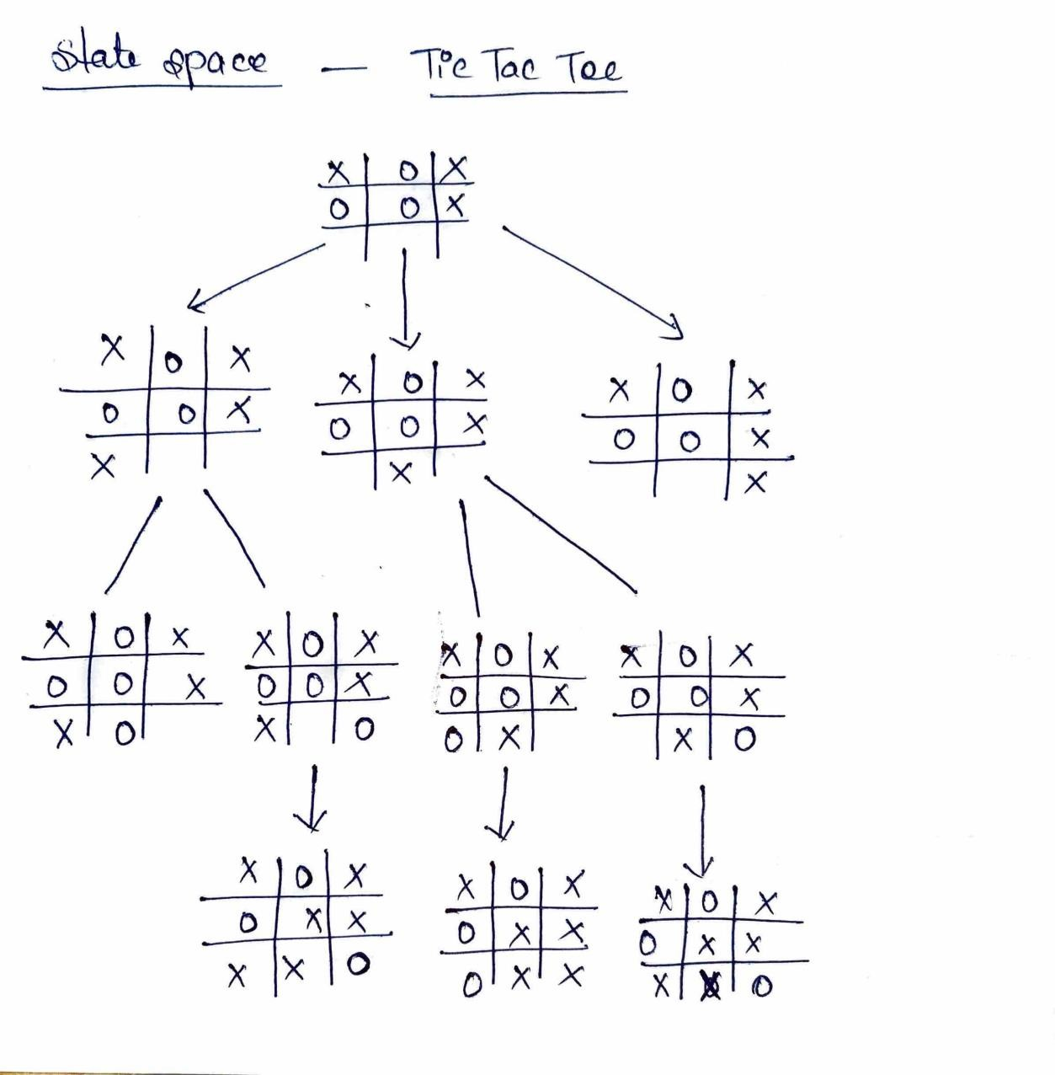

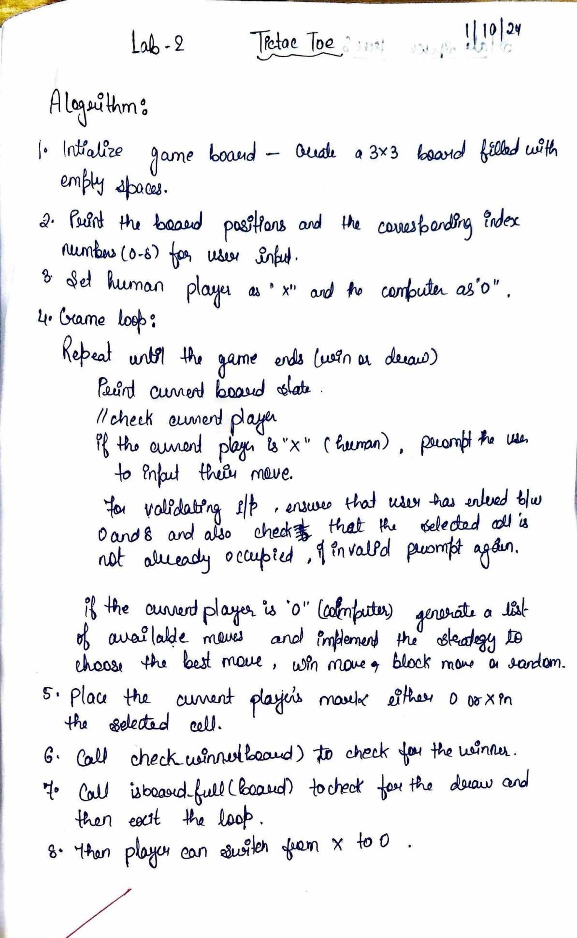

**Code:**

import random

def print_board(board): for row in board:

print(" | ".join(row))

print("-" * 9)

def check_winner(board): for row in board:

if row[0] == row[1] == row[2] != " ": return row[0]

for col in range(3):

if board[0][col] == board[1][col] == board[2][col] != " ": return board[0][col]

if board[0][0] == board[1][1] == board[2][2] != " ": return board[0][0]

if board[0][2] == board[1][1] == board[2][0] != " ": return board[0][2]

return None

def is_board_full(board):

return all(cell != " " for row in board for cell in row)

def get_available_moves(board):

return [(i, j) for i in range(3) for j in range(3) if board[i][j] == " "]

def tic_tac_toe():

board = [[" " for _ in range(3)] for _ in range(3)] current_player = "X" # Human player computer_player = "O"

print("Welcome to Tic-Tac-Toe!") print("Board positions:")

print(" 0 | 1 | 2") print(" ") print(" 3 | 4 | 5") print(" ") print(" 6 | 7 | 8")

while True: print_board(board)

if current_player == "X":

move = input(f"Player {current_player}, enter your move (0-8): ") try:

move = int(move)

row, col = divmod(move, 3) if board[row][col] != " ":

print("Invalid move. Cell already occupied. Try again.") continue

except (ValueError, IndexError):

print("Invalid input. Please enter a number between 0 and 8.") continue

else:

# Computer's turn

available_moves = get_available_moves(board)

row, col = random.choice(available_moves)

print(f"Computer ({computer_player}) chooses: {row * 3 + col}")

board[row][col] = current_player winner = check_winner(board)

if winner: print_board(board)

print(f"Player {winner} wins!") break

if is_board_full(board): print_board(board) print("It's a draw!") break

# Switch players

current_player = computer_player if current_player == "X" else "X"

if name == " main ": tic_tac_toe()

**Output:**

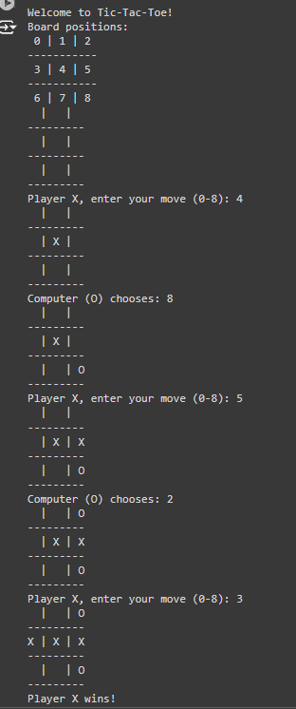

# LAB PROGRAM 2

**Solve 8 – Puzzle problems.**

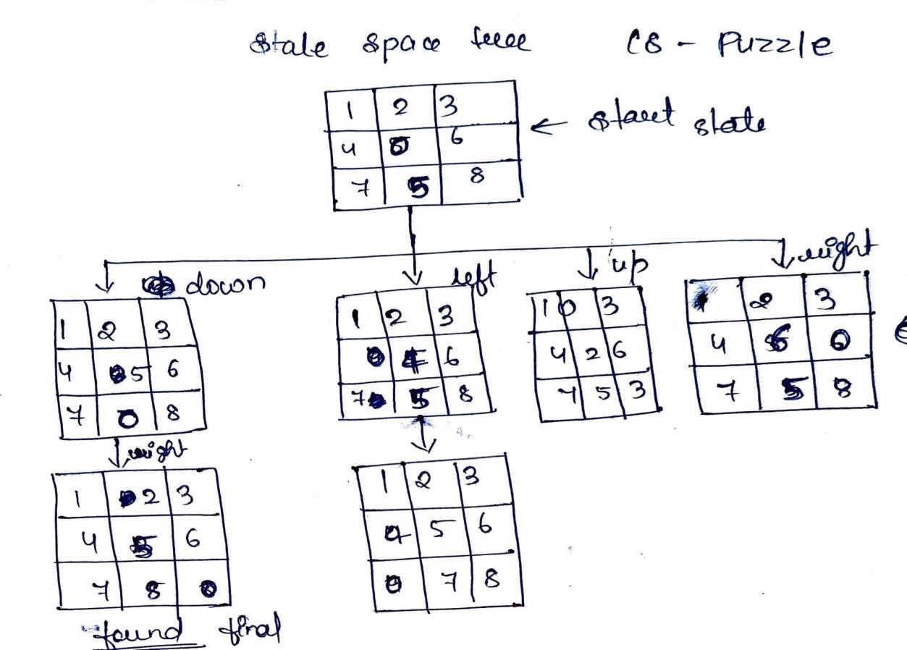

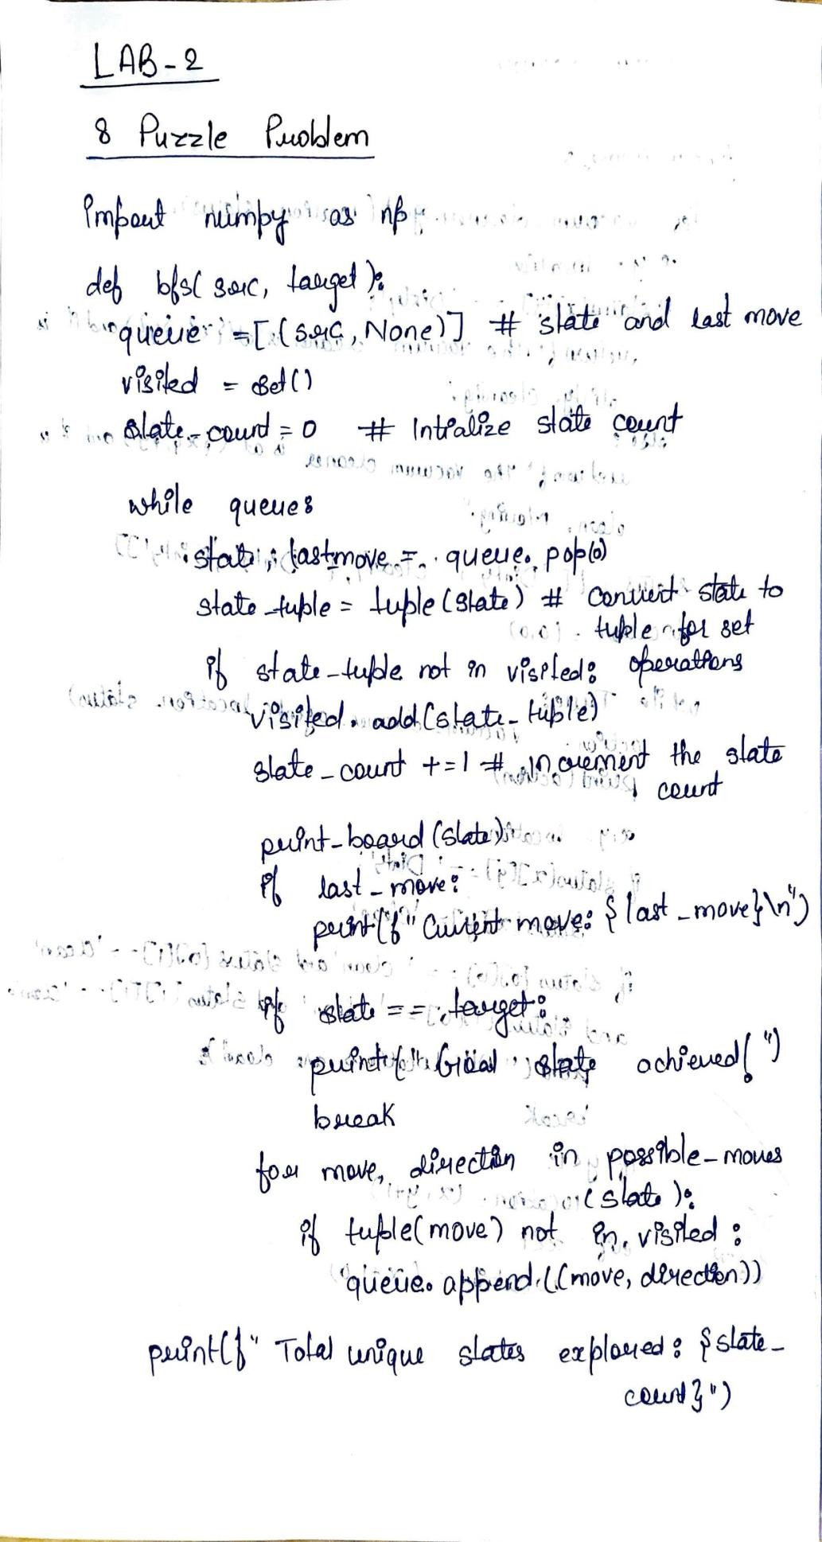

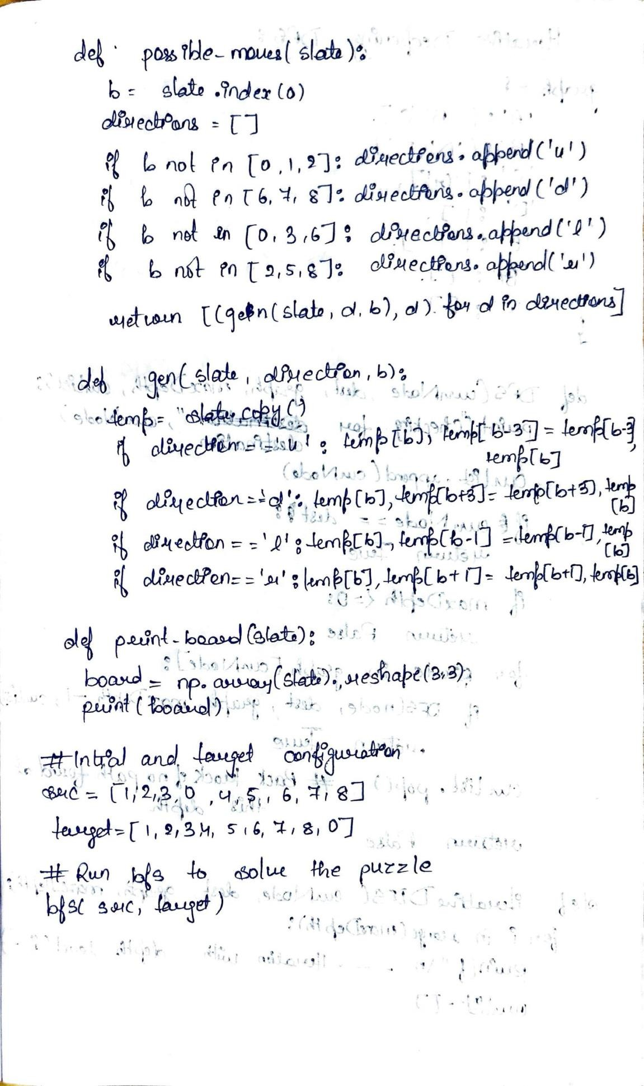

**Code:**

import numpy as np

def bfs(src, target):

queue = [(src, None)] # State and last move visited = set()

state_count = 0 # Initialize state count

while queue:

state, last_move = queue.pop(0)

state_tuple = tuple(state) # Convert state to tuple for set operations

if state_tuple not in visited: visited.add(state_tuple)

state_count += 1 # Increment the state count

print_board(state) if last_move:

print(f"Current move: {last_move}\n")

if state == target:

print("Goal state achieved!") break

for move, direction in possible_moves(state):

if tuple(move) not in visited: queue.append((move, direction))

print(f"Total unique states explored: {state_count}")

def possible_moves(state): b = state.index(0) directions = []

if b not in [0, 1, 2]: directions.append('u')

if b not in [6, 7, 8]: directions.append('d')

if b not in [0, 3, 6]: directions.append('l')

if b not in [2, 5, 8]: directions.append('r')

return [(gen(state, d, b), d) for d in directions]

def gen(state, direction, b): temp = state.copy()

if direction == 'u': temp[b], temp[b - 3] = temp[b - 3], temp[b] if direction == 'd': temp[b], temp[b + 3] = temp[b + 3], temp[b] if direction == 'l': temp[b], temp[b - 1] = temp[b - 1], temp[b] if direction == 'r': temp[b], temp[b + 1] = temp[b + 1], temp[b] return temp

def print_board(state):

board = np.array(state).reshape(3, 3) print(board)

# Initial configuration and target configuration src = [1, 2, 3, 0, 4, 6, 7, 5, 8]

target = [1, 2, 3, 4, 5, 6, 7, 8, 0]

# Run BFS to solve the puzzle bfs(src, target)

**Output:**

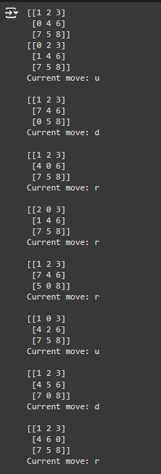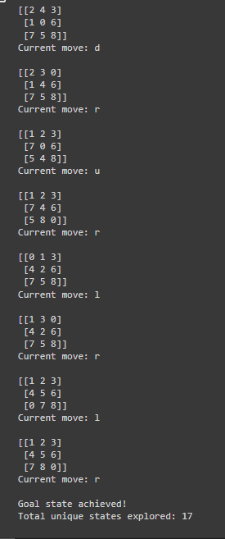

# LAB PROGRAM 3

**Implement Iterative deepening search algorithm.**

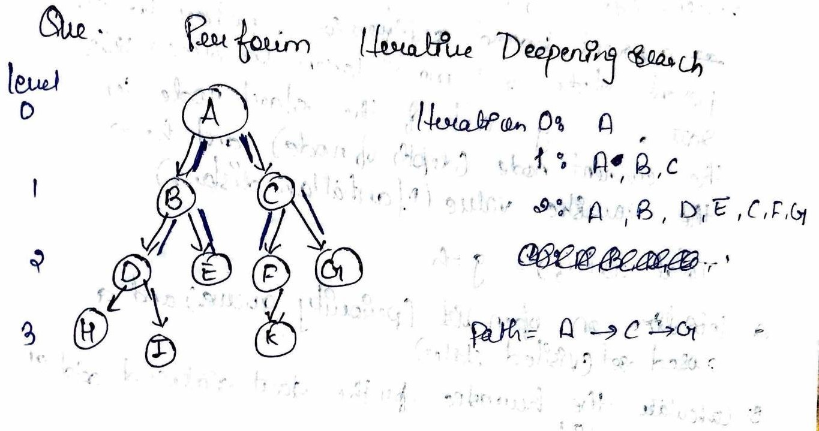

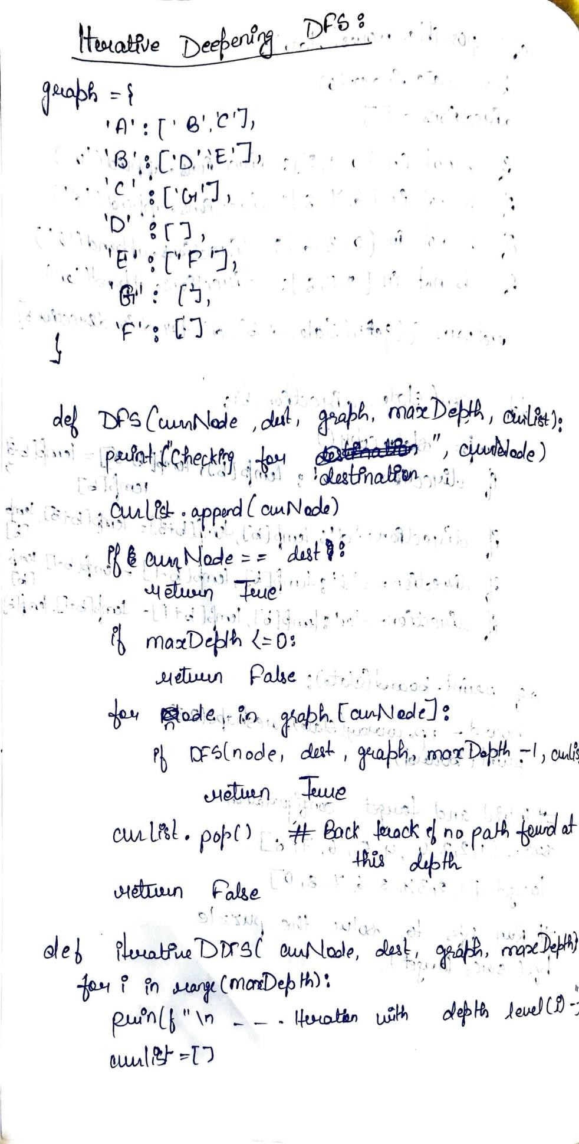

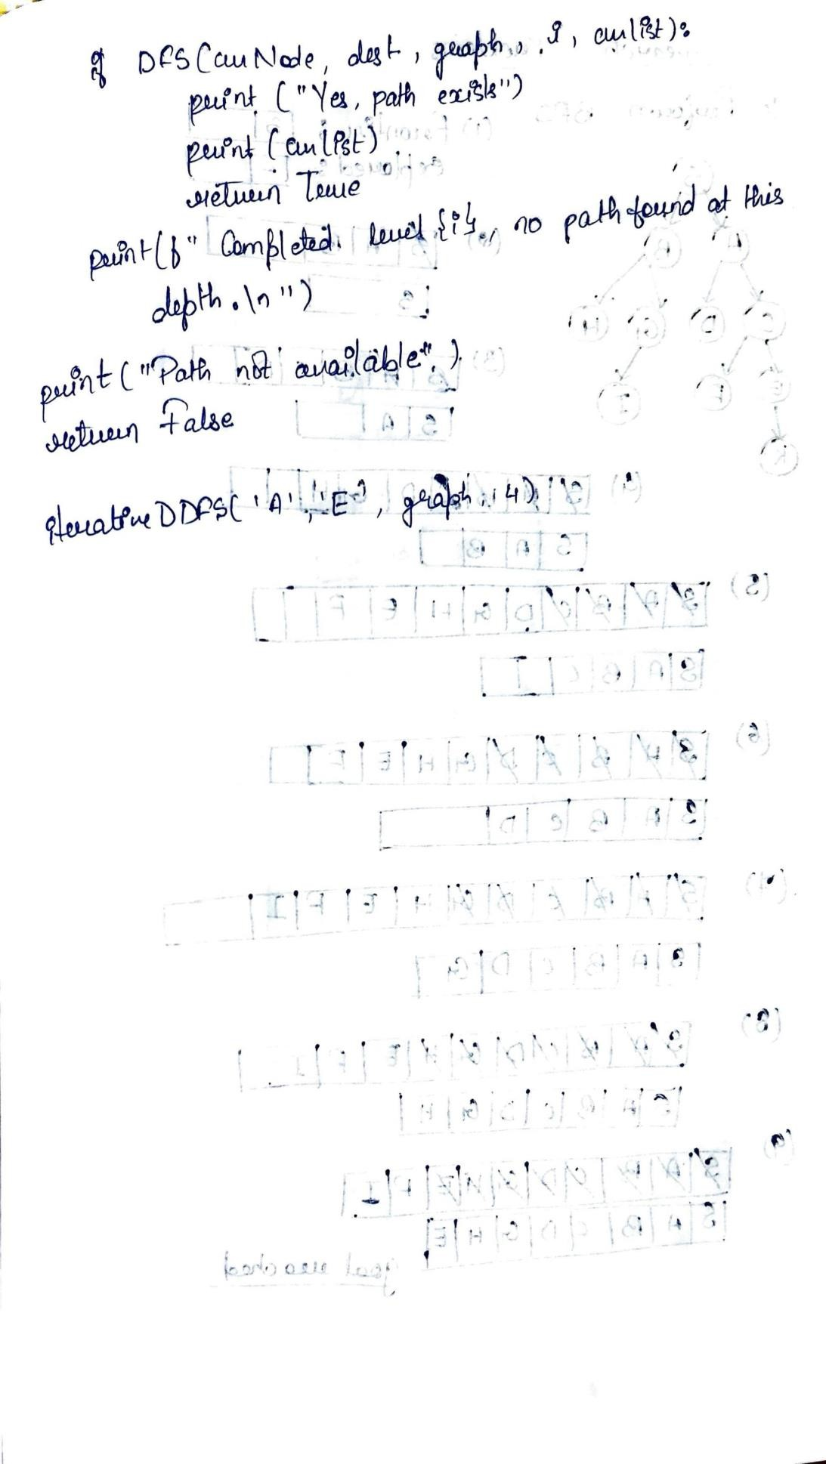



**Code:**

graph = {

'A': ['B', 'C'],

'B': ['D','E'],

"C": ['G'],

'D': [],

'E': ['F'],

'G': [],

'F':[]

}

def DFS(currentNode, destination, graph, maxDepth, curList): print("Checking for destination", currentNode) curList.append(currentNode)

if currentNode == destination: return True

if maxDepth <= 0: return False

for node in graph[currentNode]:

if DFS(node, destination, graph, maxDepth - 1, curList): return True

curList.pop() # Backtrack if no path is found at this depth return False

def iterativeDDFS(currentNode, destination, graph, maxDepth): for i in range(maxDepth):

print(f"\n--- Iteration with depth level {i} ---") curList = []

if DFS(currentNode, destination, graph, i, curList): print("Yes, path exists")

print(curList) return True

print(f"Completed level {i}, no path found at this depth.\n") print("Path is not available")

return False

# Calling the function iterativeDDFS('A', 'E', graph, 4)

**Output:**

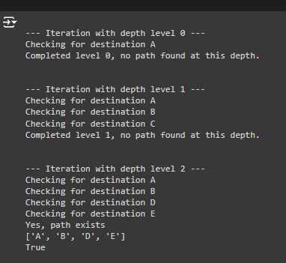

# LAB PROGRAM 4

**Implement vaccum cleaner agent.**

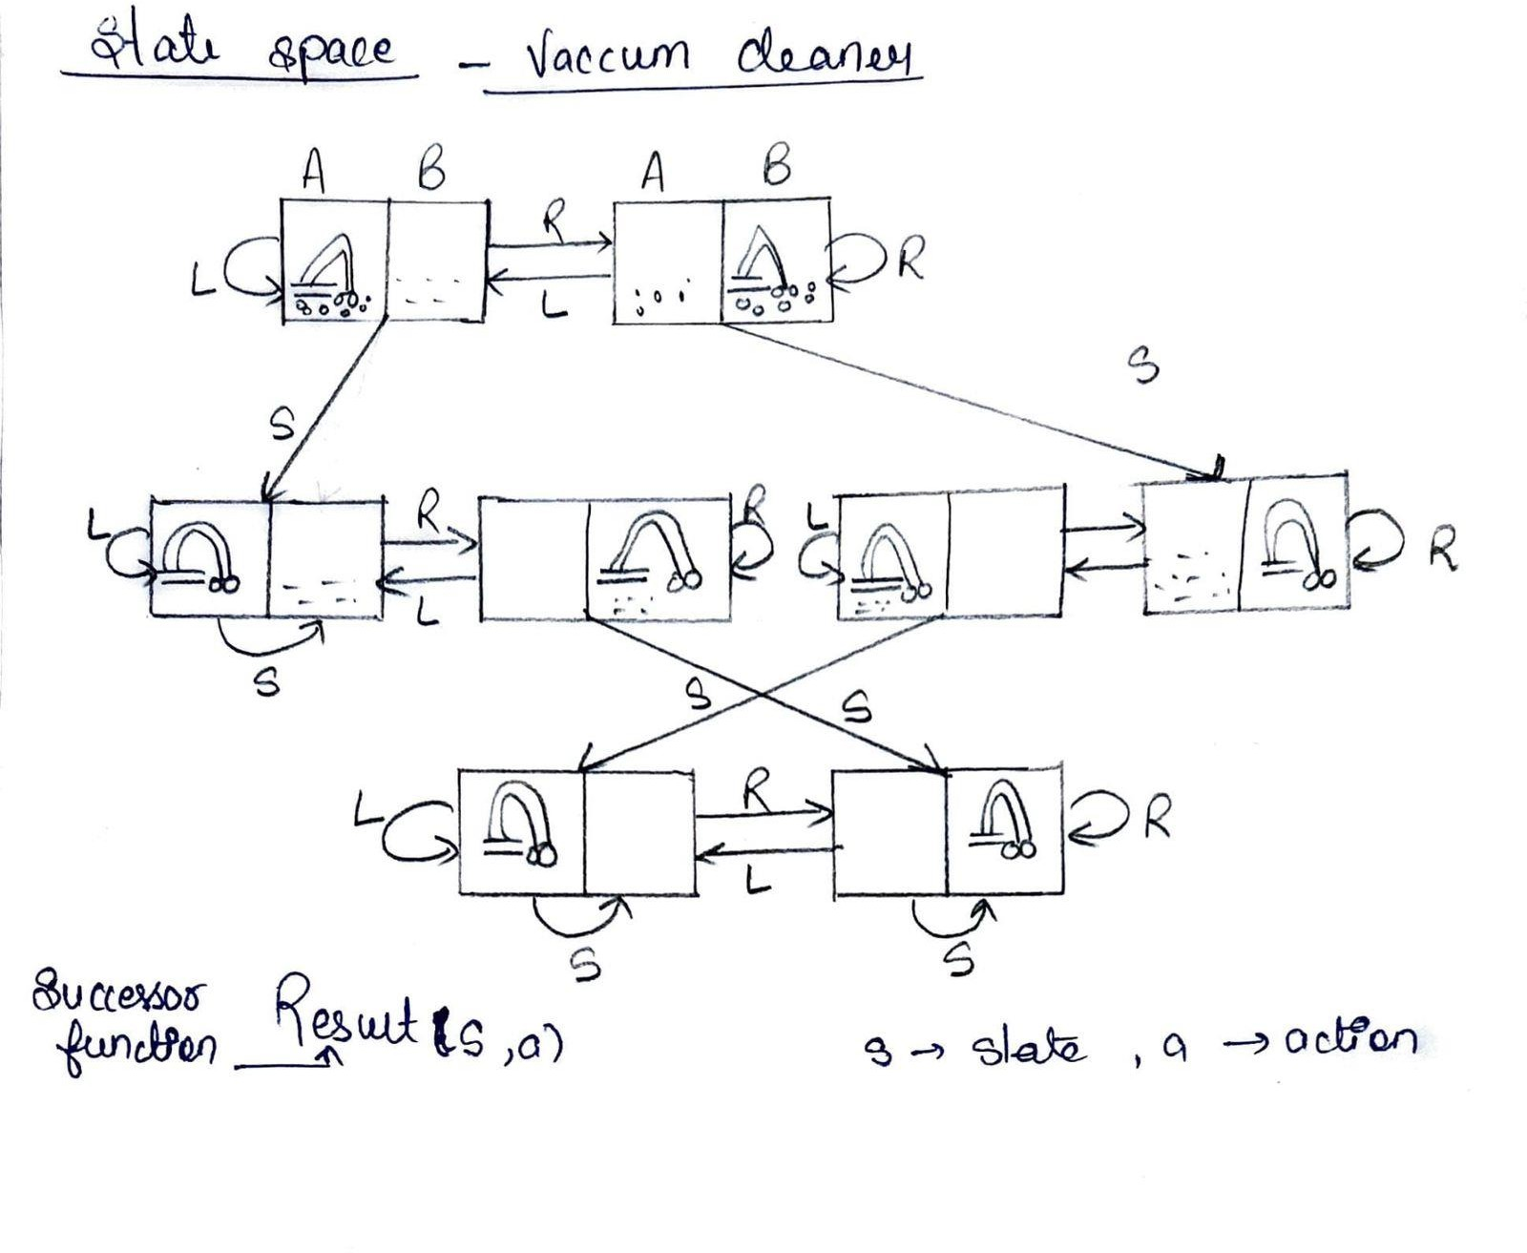

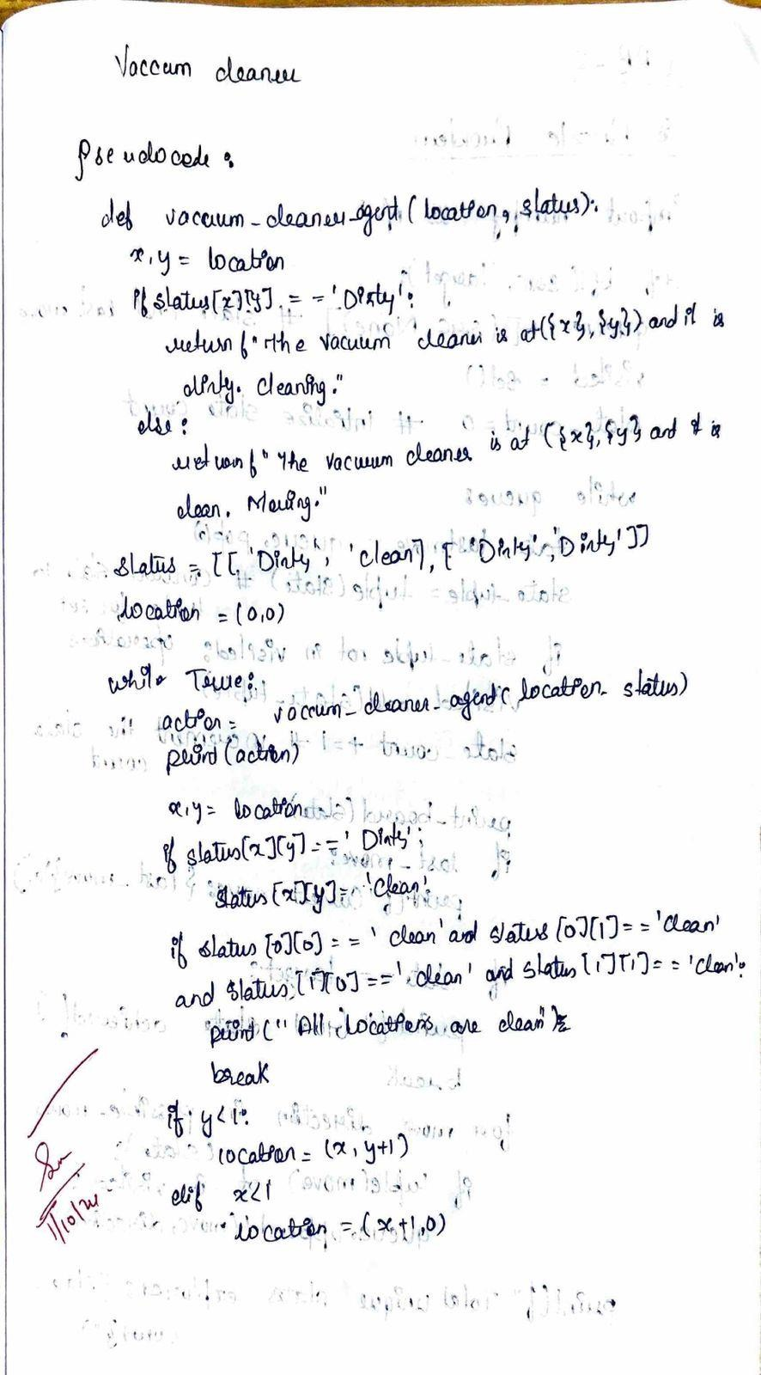

**Code:**

def vacuum_cleaner_agent(location, status): x, y = location

if status[x][y] == 'Dirty':

return f"The vacuum cleaner is at ({x}, {y}) and it is dirty. Cleaning." else:

return f"The vacuum cleaner is at ({x}, {y}) and it is clean. Moving."

status = [['Dirty', 'Clean'], ['Dirty', 'Dirty']] location = (0, 0)

while True:

action = vacuum_cleaner_agent(location, status) print(action)

x, y = location

if status[x][y] == 'Dirty': status[x][y] = 'Clean'

if status[0][0] == 'Clean' and status[0][1] == 'Clean' and status[1][0] == 'Clean' and status[1][1] == 'Clean':

print("All locations are clean. The vacuum cleaner is finished.") break

if y < 1:

location = (x, y + 1) elif x < 1:

location = (x + 1, 0)

**Output:**

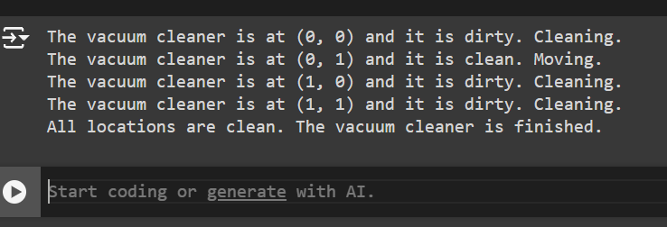

# LAB PROGRAM 5

**Implement A* search algorithm.  
  
Heuristic – Manhattan**

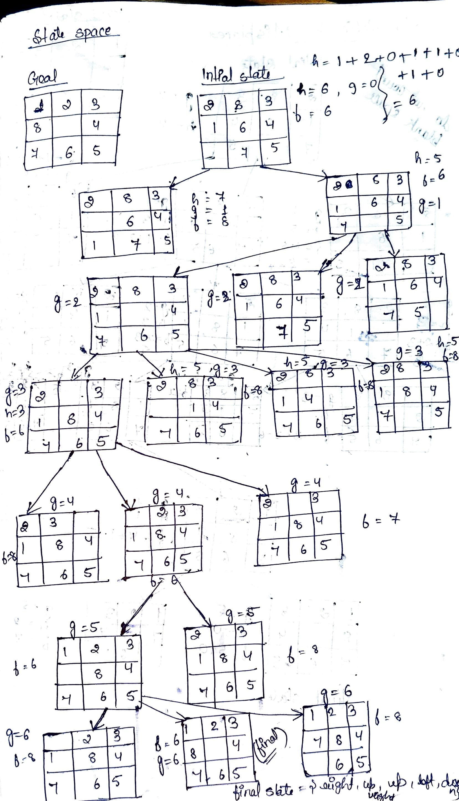

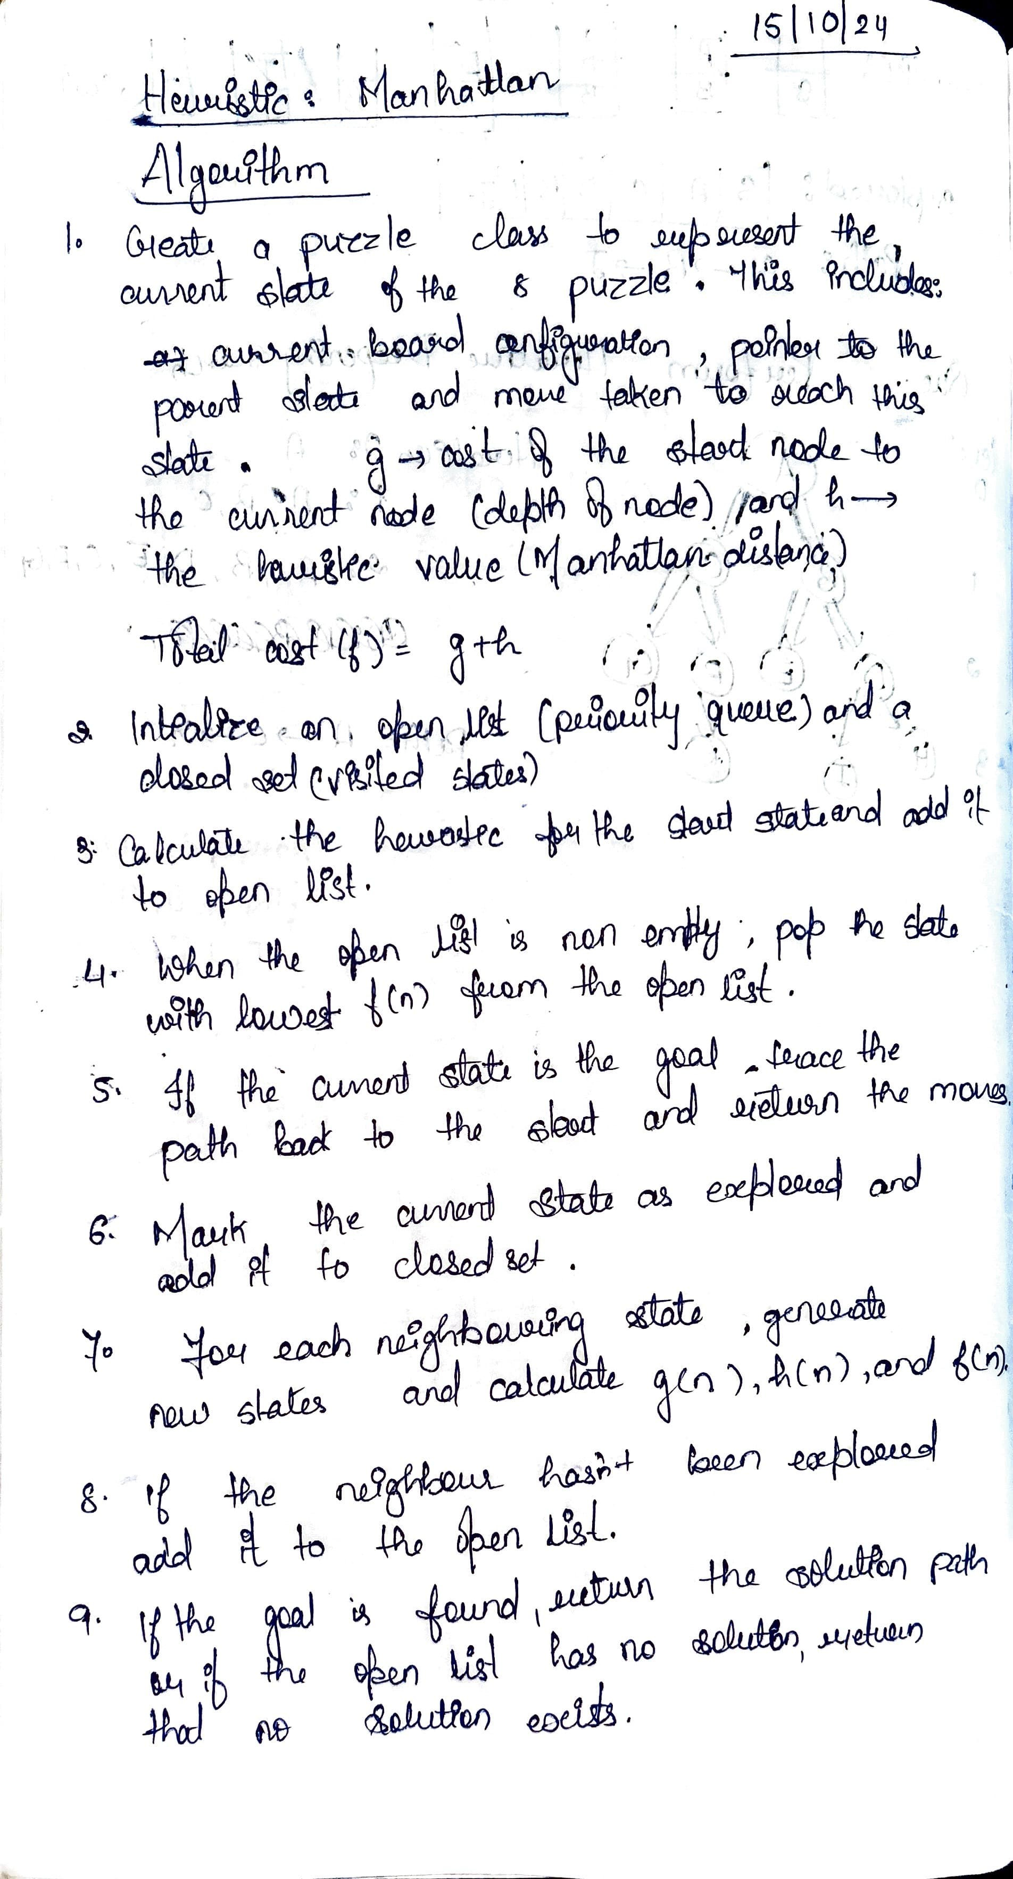

import heapq

goal_state = [[1, 2, 3],

[8, 0, 4],

[7, 6, 5]]

def find_zero(state):

for i in range(3):

for j in range(3):

if state[i][j] == 0:

return (i, j)

def move(state, direction):

new_state = [row[:] for row in state]

i, j = find_zero(state)

if direction == "up" and i > 0:

new_state[i][j], new_state[i-1][j] = new_state[i-1][j], new_state[i][j]

elif direction == "down" and i < 2:

new_state[i][j], new_state[i+1][j] = new_state[i+1][j], new_state[i][j]

elif direction == "left" and j > 0:

new_state[i][j], new_state[i][j-1] = new_state[i][j-1], new_state[i][j]

elif direction == "right" and j < 2:

new_state[i][j], new_state[i][j+1] = new_state[i][j+1], new_state[i][j]

else:

return None

return new_state

def is_goal(state):

return state == goal_state

def manhattan_distance(state):

distance = 0

for i in range(3):

for j in range(3):

if state[i][j] != 0:

goal_i, goal_j = divmod(state[i][j] - 1, 3)

if state[i][j] == 8:

goal_i, goal_j = 1, 1

distance += abs(goal_i - i) + abs(goal_j - j)

return distance

def a_star(initial_state):

priority_queue = []

heapq.heappush(priority_queue, (0, initial_state, [], 0))

visited = set()

while priority_queue:

f, state, path, g = heapq.heappop(priority_queue)

print("Exploring state in A*:")

print_state(state)

if is_goal(state):

return path

visited.add(tuple(map(tuple, state)))

for direction in ["up", "down", "left", "right"]:

new_state = move(state, direction)

if new_state and tuple(map(tuple, new_state)) not in visited:

h = manhattan_distance(new_state)

new_g = g + 1

new_f = new_g + h

heapq.heappush(priority_queue, (new_f, new_state, path + [direction], new_g))

return None

def print_state(state):

for row in state:

print(row)

print()

def get_initial_state():

print("Enter the initial state of the 8-puzzle (0 for empty space):")

initial_state = []

for i in range(3):

row = list(map(int, input(f"Enter row {i+1} (space-separated): ").strip().split()))

if len(row) != 3:

raise ValueError("Each row must contain exactly 3 numbers.")

initial_state.append(row)

return initial_state

if __name__ == "__main__":

initial_state = get_initial_state()

print("Initial State:")

print_state(initial_state)

print("Solving using A* search:")

a_star_solution = a_star(initial_state)

if a_star_solution:

print("A* Solution:", a_star_solution)

else:

print("No solution found with A*.")

"""

Output

Enter the initial state (0 for empty space):

Enter row 1 (space-separated): 2 8 3

Enter row 2 (space-separated): 1 6 4

Enter row 3 (space-separated): 0 7 5

Initial State:

[2, 8, 3]

[1, 6, 4]

[0, 7, 5]

Solving using A* search:

Exploring state in A*:

[2, 8, 3]

[1, 6, 4]

[0, 7, 5]

Exploring state in A*:

[2, 8, 3]

[1, 6, 4]

[7, 0, 5]

Exploring state in A*:

[2, 8, 3]

[1, 6, 4]

[7, 5, 0]

Exploring state in A*:

[2, 8, 3]

[0, 6, 4]

[1, 7, 5]

Exploring state in A*:

[2, 8, 3]

[1, 0, 4]

[7, 6, 5]

Exploring state in A*:

[2, 0, 3]

[1, 8, 4]

[7, 6, 5]

Exploring state in A*:

[0, 2, 3]

[1, 8, 4]

[7, 6, 5]

Exploring state in A*:

[1, 2, 3]

[0, 8, 4]

[7, 6, 5]

Exploring state in A*:

[2, 8, 3]

[1, 4, 0]

[7, 6, 5]

Exploring state in A*:

[2, 8, 3]

[1, 4, 5]

[7, 6, 0]

Exploring state in A*:

[2, 8, 3]

[1, 4, 5]

[7, 0, 6]

Exploring state in A*:

[2, 8, 3]

[1, 6, 0]

[7, 5, 4]

Exploring state in A*:

[2, 8, 3]

[1, 0, 6]

[7, 5, 4]

Exploring state in A*:

[2, 0, 3]

[1, 8, 6]

[7, 5, 4]

Exploring state in A*:

[0, 2, 3]

[1, 8, 6]

[7, 5, 4]

Exploring state in A*:

[1, 2, 3]

[0, 8, 6]

[7, 5, 4]

Exploring state in A*:

[2, 8, 3]

[1, 5, 6]

[7, 0, 4]

Exploring state in A*:

[2, 8, 3]

[1, 5, 6]

[7, 4, 0]

Exploring state in A*:

[0, 8, 3]

[2, 6, 4]

[1, 7, 5]

Exploring state in A*:

[1, 2, 3]

[7, 8, 4]

[0, 6, 5]

Exploring state in A*:

[1, 2, 3]

[7, 8, 6]

[0, 5, 4]

Exploring state in A*:

[1, 2, 3]

[8, 0, 4]

[7, 6, 5]

A* Solution: ['right', 'up', 'up', 'left', 'down', 'right']

"""

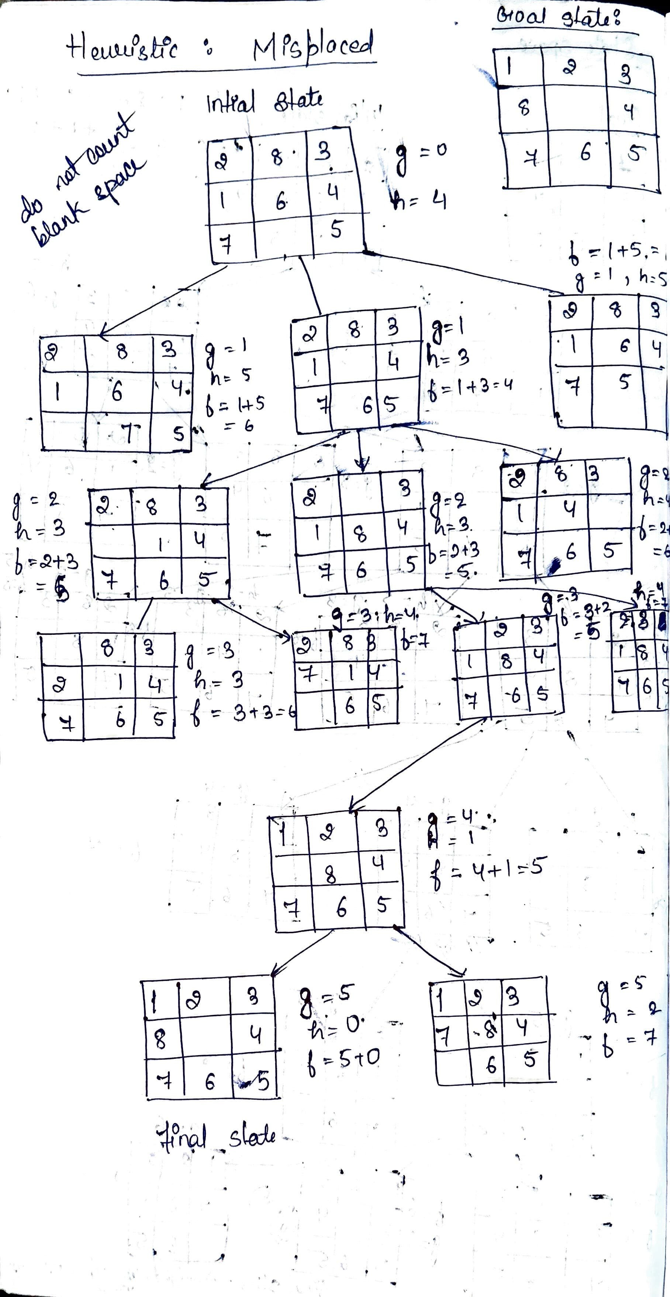**Heuristic – Mismatched Tiles**

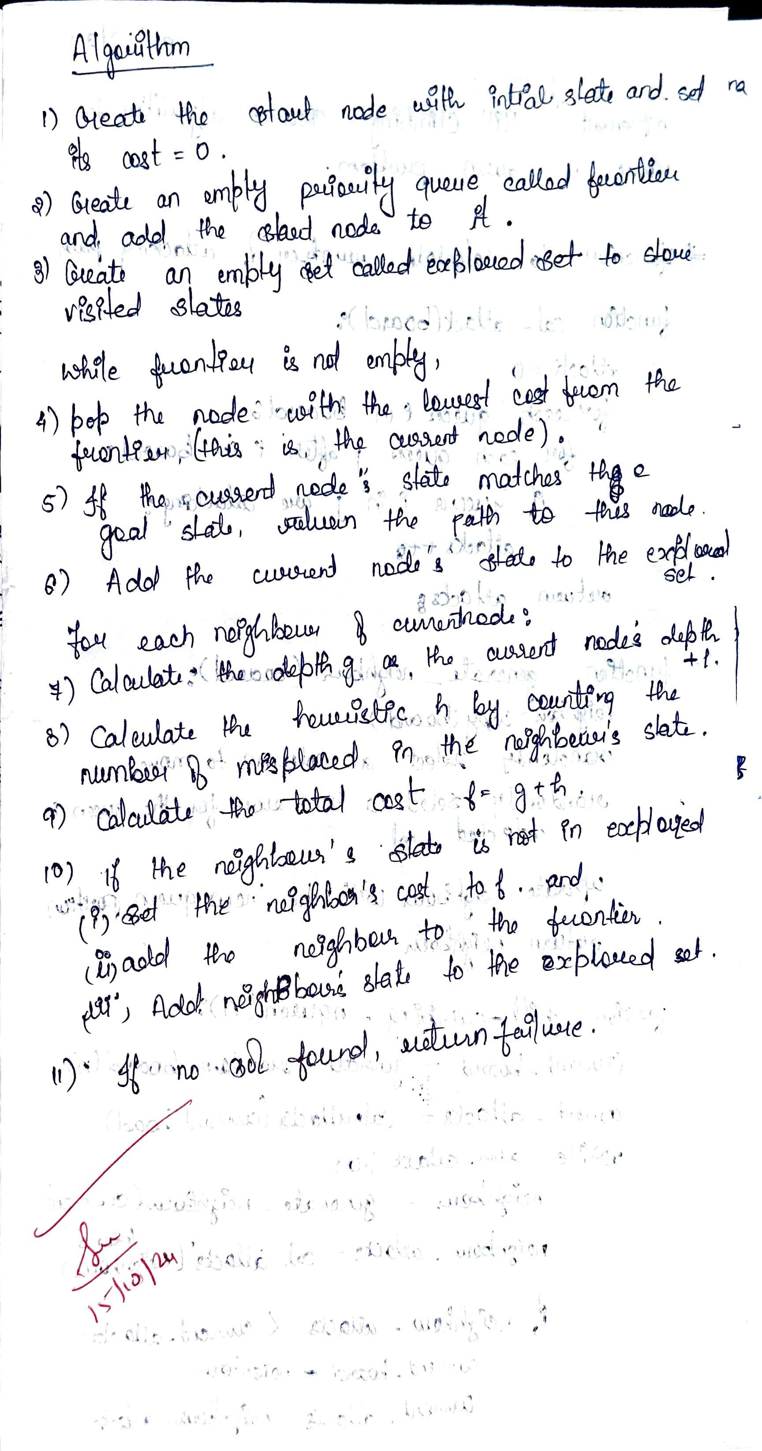

import heapq

goal_state = [[1, 2, 3],

[8, 0, 4],

[7, 6, 5]]

def find_zero(state):

for i in range(3):

for j in range(3):

if state[i][j] == 0:

return (i, j)

def move(state, direction):

new_state = [row[:] for row in state]

i, j = find_zero(state)

if direction == "up" and i > 0:

new_state[i][j], new_state[i-1][j] = new_state[i-1][j], new_state[i][j]

elif direction == "down" and i < 2:

new_state[i][j], new_state[i+1][j] = new_state[i+1][j], new_state[i][j]

elif direction == "left" and j > 0:

new_state[i][j], new_state[i][j-1] = new_state[i][j-1], new_state[i][j]

elif direction == "right" and j < 2:

new_state[i][j], new_state[i][j+1] = new_state[i][j+1], new_state[i][j]

else:

return None

return new_state

def is_goal(state):

return state == goal_state

def misplaced_tiles(state):

return sum(1 for i in range(3) for j in range(3)

if state[i][j] != goal_state[i][j] and state[i][j] != 0)

def a_star(initial_state):

priority_queue = []

heapq.heappush(priority_queue, (0, initial_state, [], 0))

visited = set()

while priority_queue:

f, state, path, g = heapq.heappop(priority_queue)

print("Exploring state in A*:")

print_state(state)

if is_goal(state):

return path

visited.add(tuple(map(tuple, state)))

for direction in ["up", "down", "left", "right"]:

new_state = move(state, direction)

if new_state and tuple(map(tuple, new_state)) not in visited:

h = misplaced_tiles(new_state)

new_g = g + 1

new_f = new_g + h

heapq.heappush(priority_queue, (new_f, new_state, path + [direction], new_g))

return None

def print_state(state):

for row in state:

print(row)

print()

def get_initial_state():

print("Enter the initial state (0 for empty space):")

initial_state = []

for i in range(3):

row = list(map(int, input(f"Enter row {i+1} (space-separated): ").strip().split()))

if len(row) != 3:

raise ValueError("Each row must contain exactly 3 numbers.")

initial_state.append(row)

return initial_state

if __name__ == "__main__":

initial_state = get_initial_state()

print("Initial State:")

print_state(initial_state)

print("Solving using A* search:")

a_star_solution = a_star(initial_state)

if a_star_solution:

print("A* Solution:", a_star_solution)

else:

print("No solution found with A*.")

"""

**Output**

Enter the initial state (0 for empty space):

Enter row 1 (space-separated): 2 8 3

Enter row 2 (space-separated): 1 6 4

Enter row 3 (space-separated): 0 7 5

Initial State:

[2, 8, 3]

[1, 6, 4]

[0, 7, 5]

Solving using A* search:

Exploring state in A*:

[2, 8, 3]

[1, 6, 4]

[0, 7, 5]

Exploring state in A*:

[2, 8, 3]

[1, 6, 4]

[7, 0, 5]

Exploring state in A*:

[2, 8, 3]

[1, 0, 4]

[7, 6, 5]

Exploring state in A*:

[2, 0, 3]

[1, 8, 4]

[7, 6, 5]

Exploring state in A*:

[0, 2, 3]

[1, 8, 4]

[7, 6, 5]

Exploring state in A*:

[1, 2, 3]

[0, 8, 4]

[7, 6, 5]

Exploring state in A*:

[1, 2, 3]

[8, 0, 4]

[7, 6, 5]

A* Solution: ['right', 'up', 'up', 'left', 'down', 'right']

"""

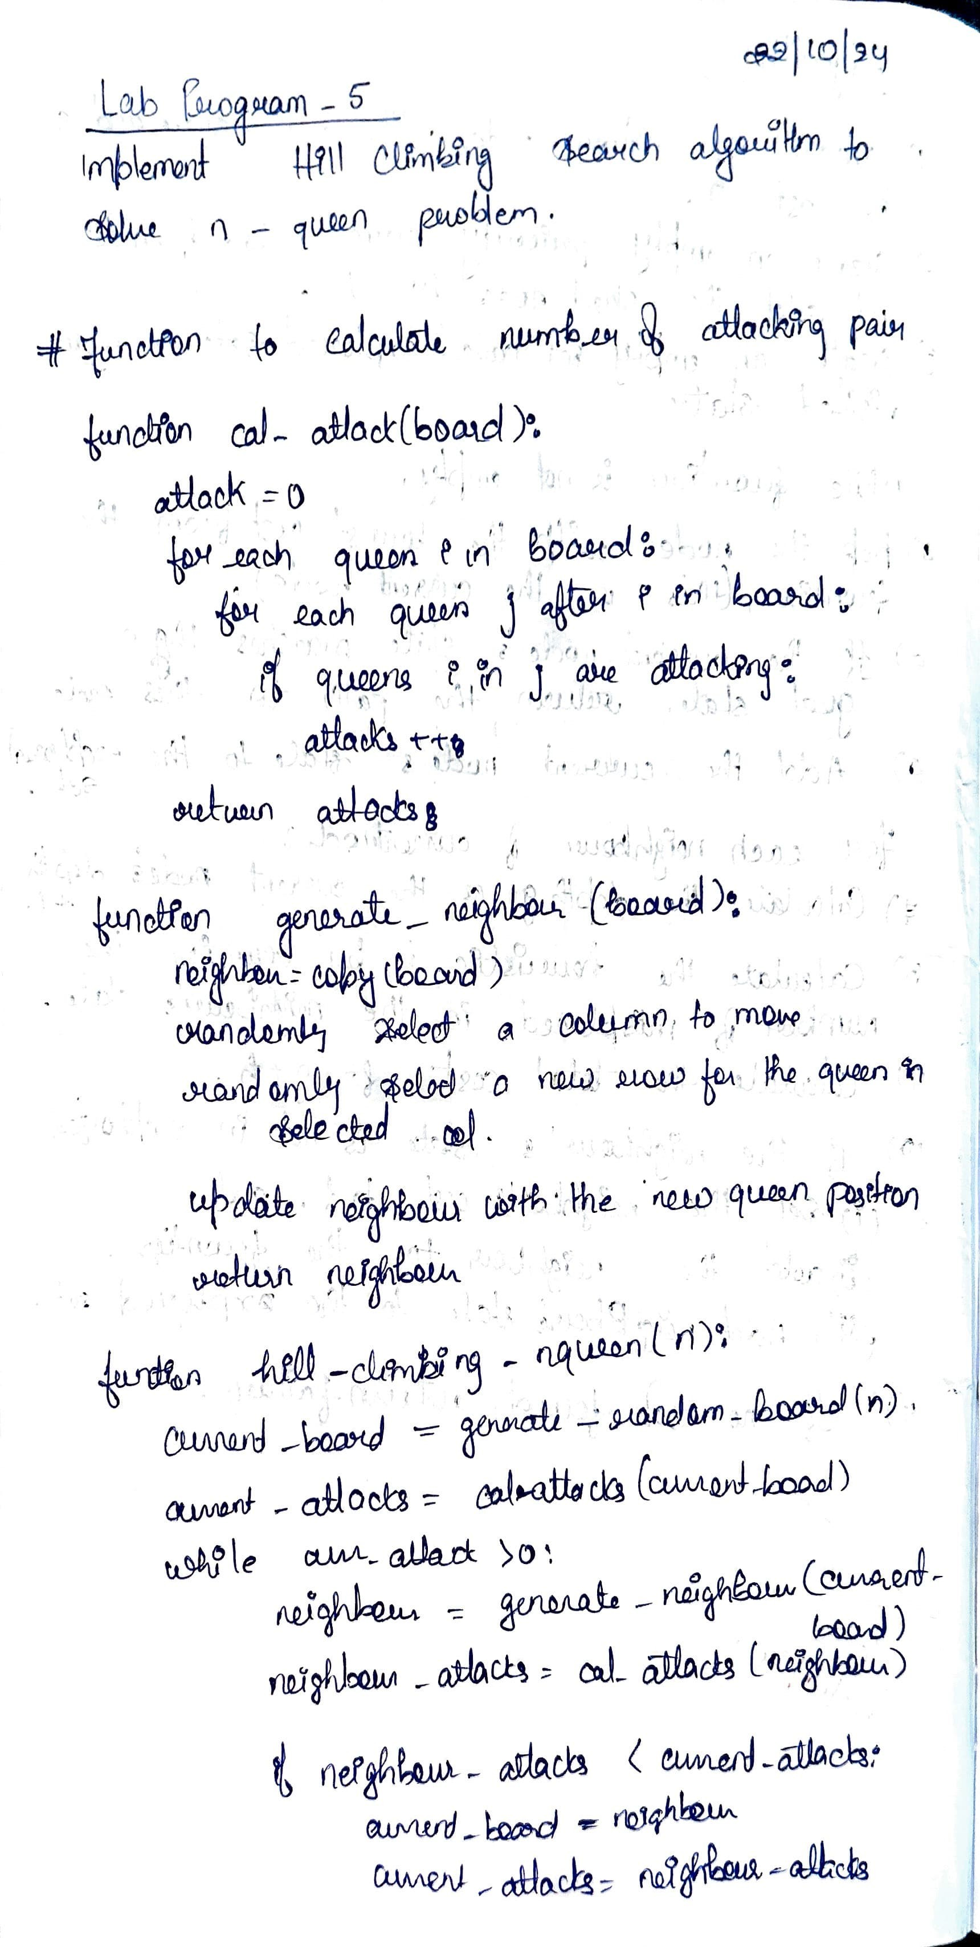**Implement Hill Climbing Algorithm.**

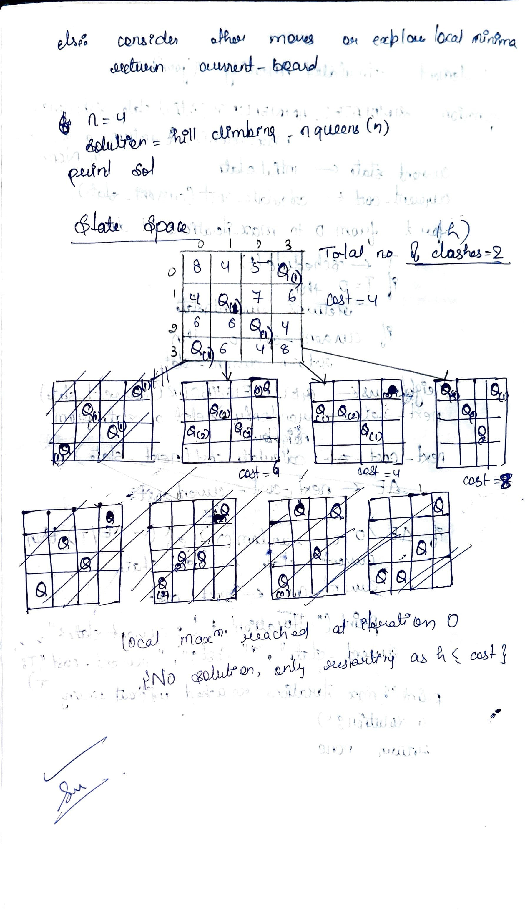  


**Implement Hill Climbing search algorithm to solve N-Queens problem**

import random

def is_safe(board, row, col, n):

"""Checks if it's safe to place a queen at the given position."""

for i in range(row):

if board[i] == col or \

abs(board[i] - col) == row - i:

return False

return True

def calculate_heuristic(board, n):

"""Calculates the number of pairs of queens attacking each other."""

heuristic_value = 0

for i in range(n):

for j in range(i + 1, n):

if board[i] == board[j] or abs(board[i] - board[j]) == j - i:

heuristic_value += 1

return heuristic_value

def hill_climbing_nqueens(n):

"""Solves the N-Queens problem using hill climbing."""

current_board = [random.randint(0, n - 1) for _ in range(n)]

current_heuristic = calculate_heuristic(current_board, n)

while True:

neighbors = []

for row in range(n):

for col in range(n):

if current_board[row] != col:

neighbor_board = current_board[:]

neighbor_board[row] = col

neighbors.append(neighbor_board)

best_neighbor = None

best_neighbor_heuristic = current_heuristic

for neighbor in neighbors:

neighbor_heuristic = calculate_heuristic(neighbor, n)

if neighbor_heuristic < best_neighbor_heuristic:

best_neighbor_heuristic = neighbor_heuristic

best_neighbor = neighbor

if best_neighbor is None:

break # No better neighbor found, local optima reached

current_board = best_neighbor

current_heuristic = best_neighbor_heuristic

return current_board, current_heuristic

def print_board(board):

n = len(board)

for row in range(n):

line = ""

for col in range(n):

if board[row] == col:

line += "Q "

else:

line += ". "

print(line)

# Example usage for 8-Queens

n = 8

solution, heuristic = hill_climbing_nqueens(n)

if heuristic == 0:

print("Solution found:")

print_board(solution)

else:

print("Local optima reached, not a perfect solution.")

print("Heuristic value:", heuristic)

print_board(solution)

# LAB PROGRAM 6

**Write a program to implement Simulated Annealing Algorithm**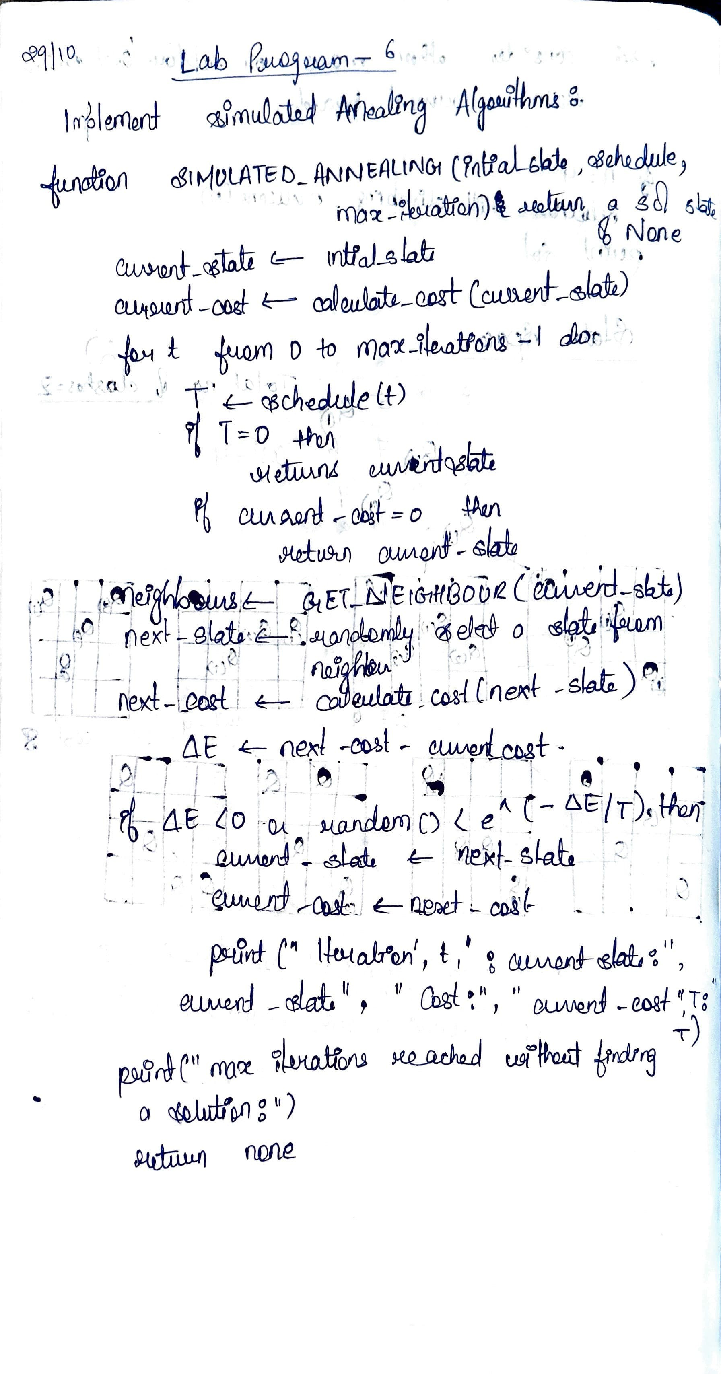

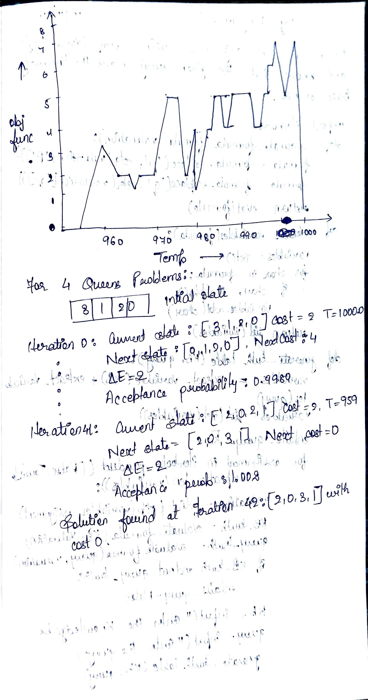

# LAB PROGRAM 7

**Create a knowledge base using prepositional logic and show that the given query entails the knowledge base or not.**

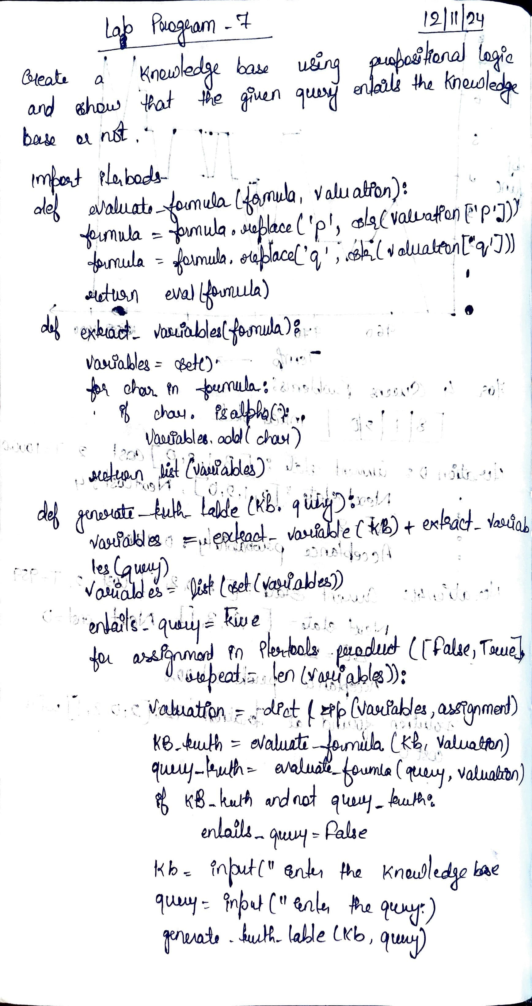

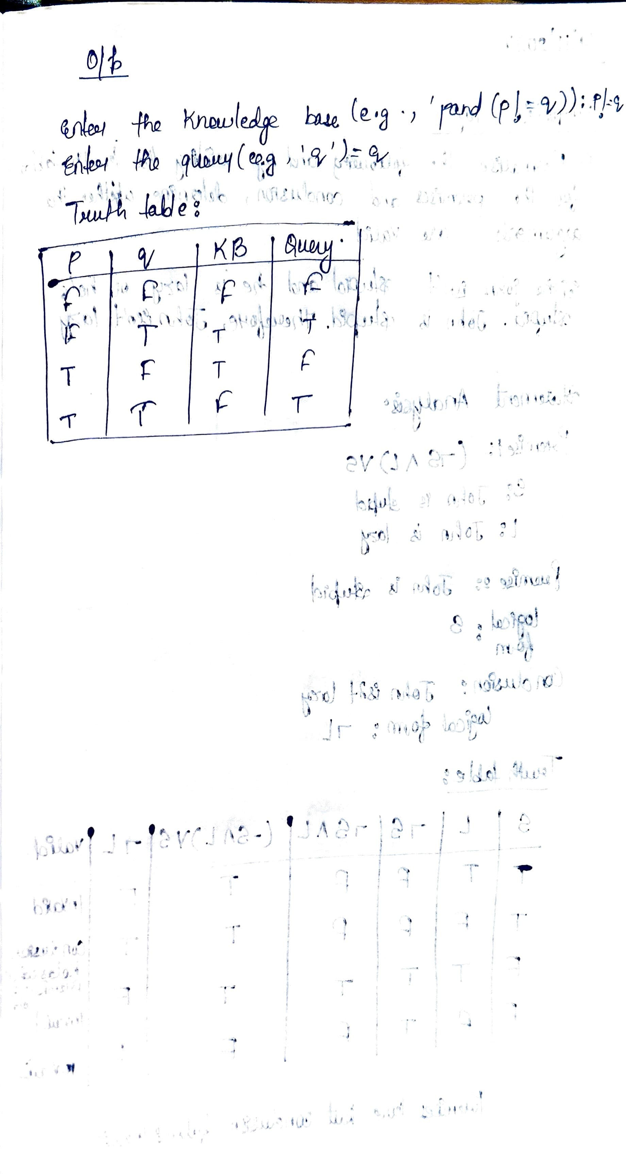

**Lab Program and exercise - 19/11/2024  
  
Preposition Logic**

1. Formalise the following and, by writing truth tables for the premises and conclusion, determine whether the arguments are valid.

Either John isn’t stupid and he is lazy, or he’s stupid. John is stupid. Therefore, John isn’t lazy.

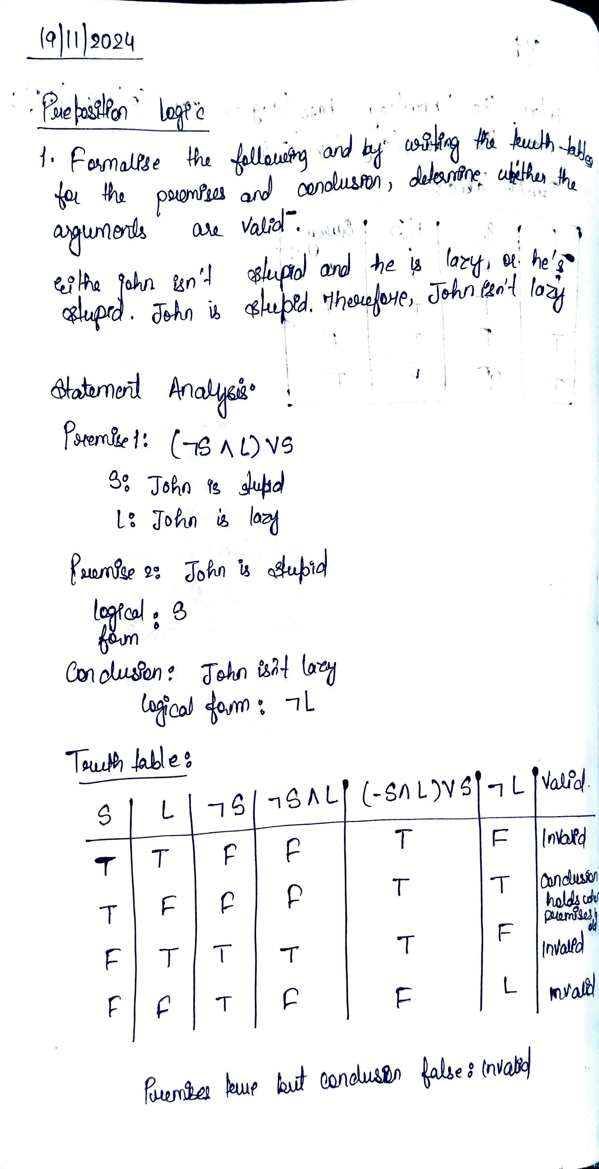

2. Give a truth-table definition of the ternary boolean operation if P then Q else R.  
  
**First Order Logic**

First-order logic (FOL) is a formal system used to represent statements about the world. In FOL,

sentences are made up of predicates, variables, constants, functions, and logical connectives.

1. Below are examples of natural language sentences.

● Translate them into first-order logic:

● Also write and implement a python program that performs a basic transformation of simple sentences into FOL.

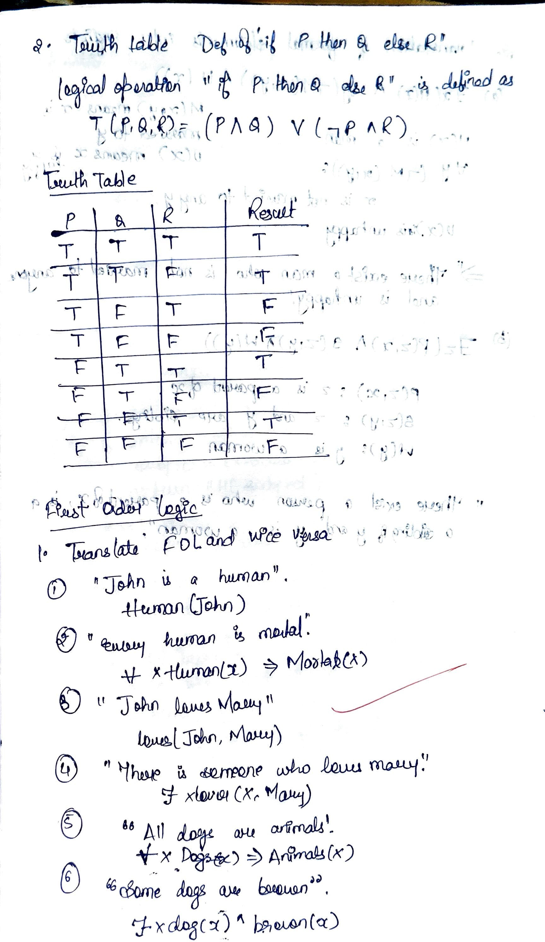

2. Translate the following into English sentences.

(a) x.(H(x) y.¬M(x,y)) U(x) where H(x) means x is a man, M(x,y) means x is married to y, U(x) means x is unhappy, and x and y range over people.

(b) z.P(z,x) S(z,y) W(y) where P(z,x) means z is a parent of x, S(z,y) means z and y are siblings, W(y) means y is a woman, and x, y, and z range over people.

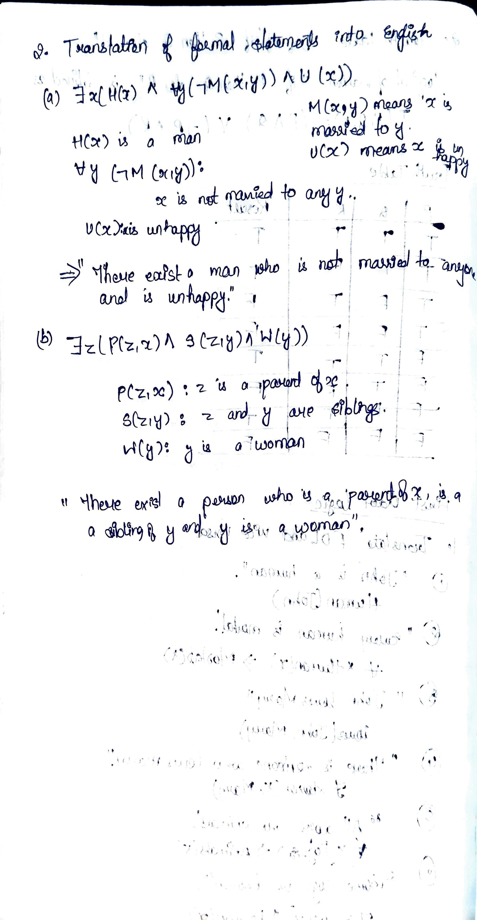

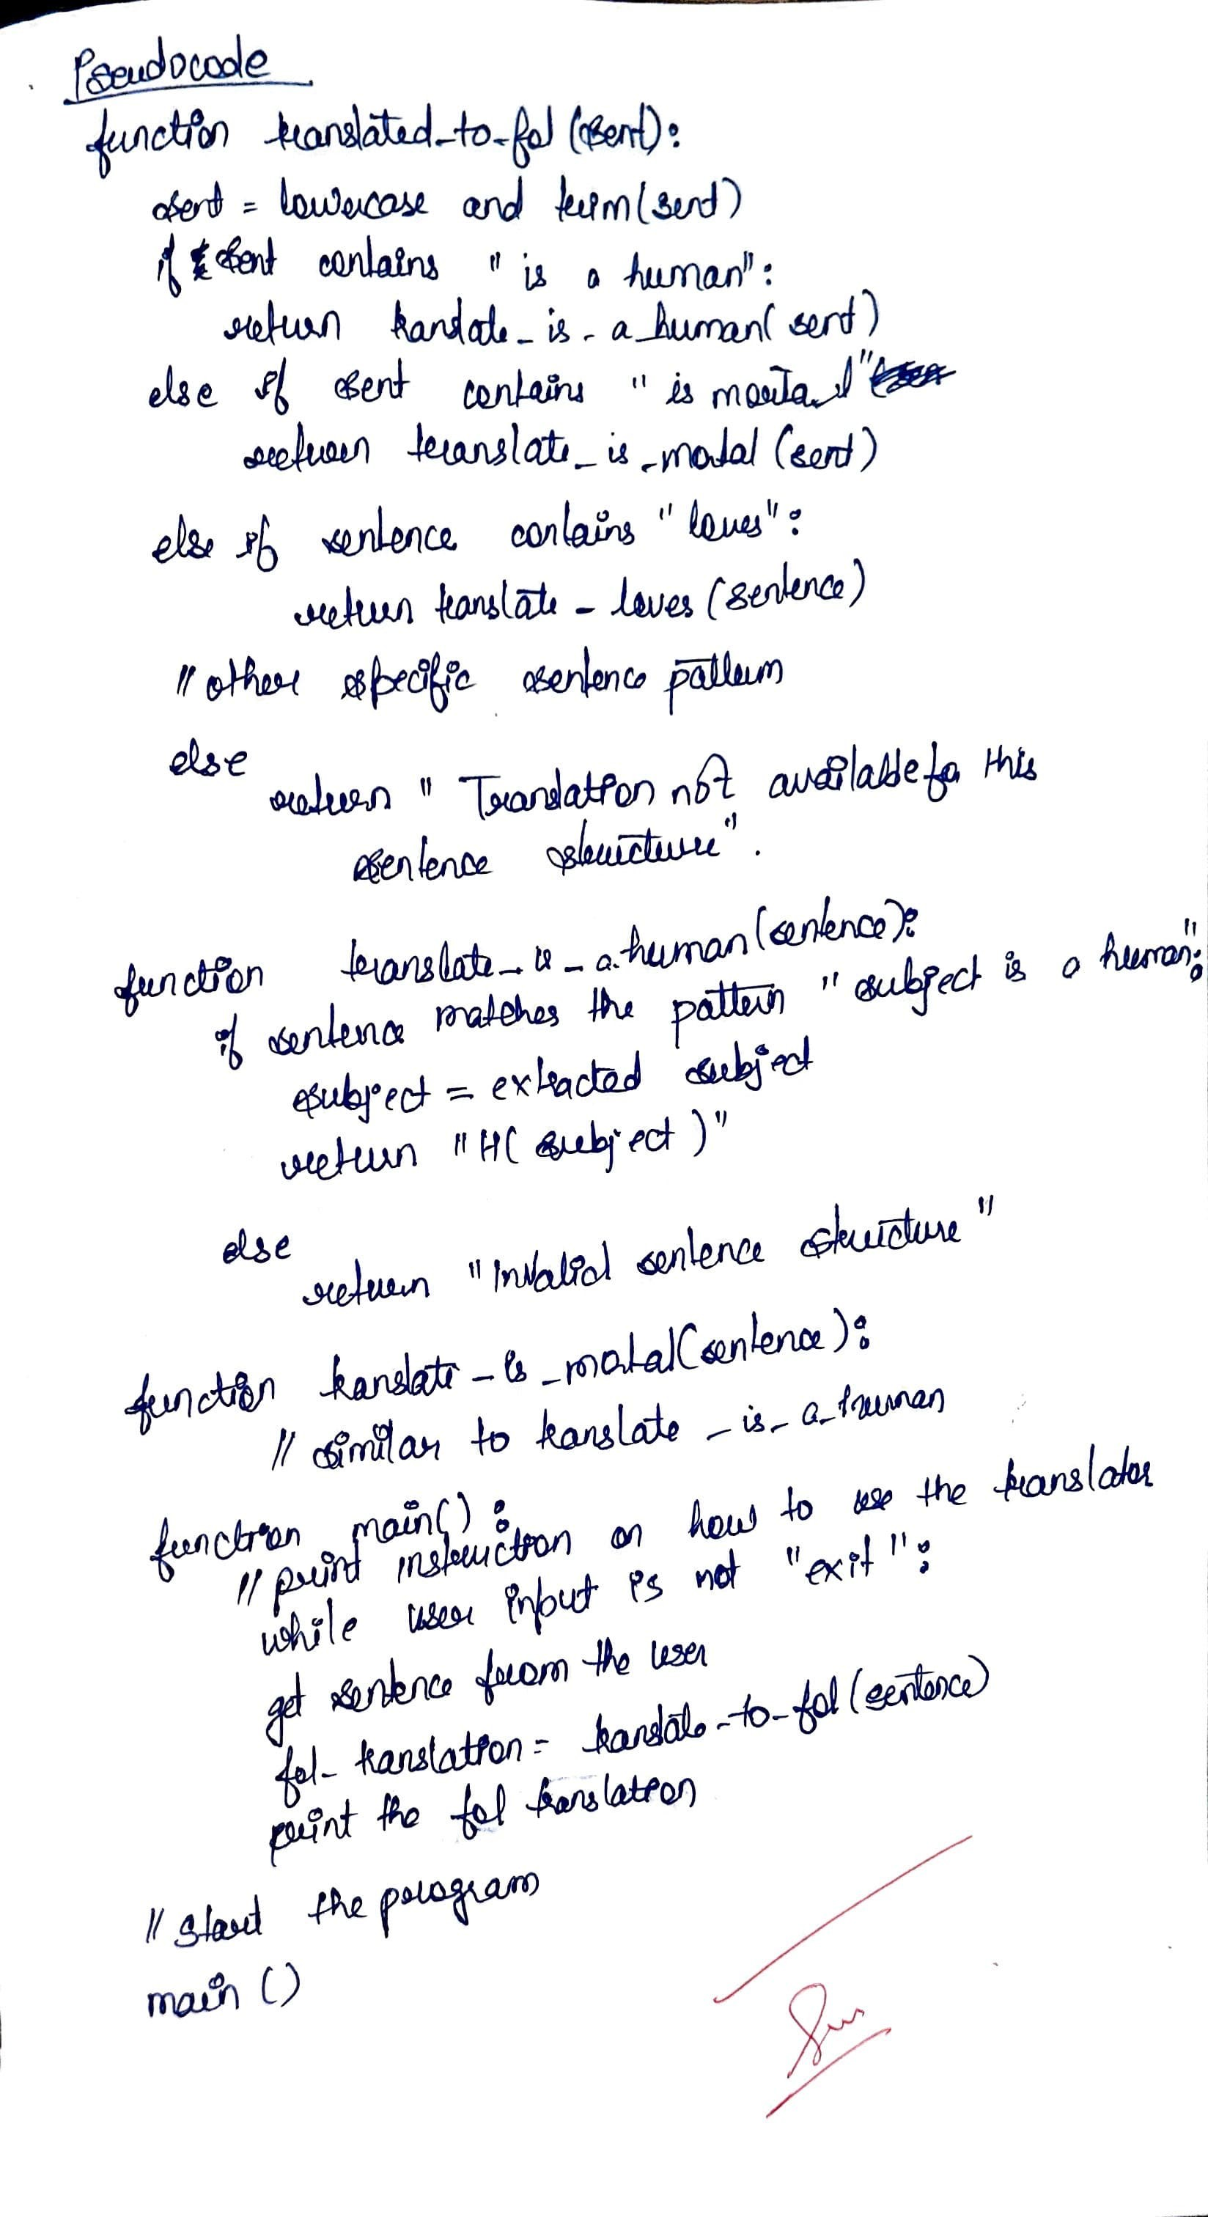

# LAB PROGRAM 8

**Create a knowledge base using prepositional logic and show that the given query entails the knowledge base or not.**